Fool everyone with a vacation picture to a place you’ve never been!
YOUTH MEDIA LAB @ media bridges

What you need:
- A picture of yourself (bring your own or take one with the PhotoBooth program on the Macs)
- A picture of a place you want to visit
- Photoshop Elements

Picture of yourself- if you have an online photo account, get a picture from there.

OR – Take a picture using the computer.
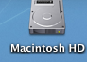
HOW: 1. Open the Macintosh HD icon, top, right corner

- Go to the Applications folder
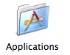

- Open the Photo Booth Program
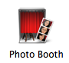
(scroll down to find it)

- If you do not see yourself on the screen, click on the circular camera button to activate the camera. It should be red.


- Pose and Smile for the camera!

- When you have your picture, import the picture to Photoshop Elements. To do this, put the cursor (the arrow) on your picture. Click and HOLD down the mouse. Now you can drag the picture into the Photoshop Elements icon in the bottom of your screen.
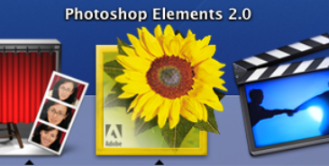
This is the Photoshop Elements icon located in the dock
(it pops up when the cursor is at the bottom of the screen)

Here’s the Photo Booth program
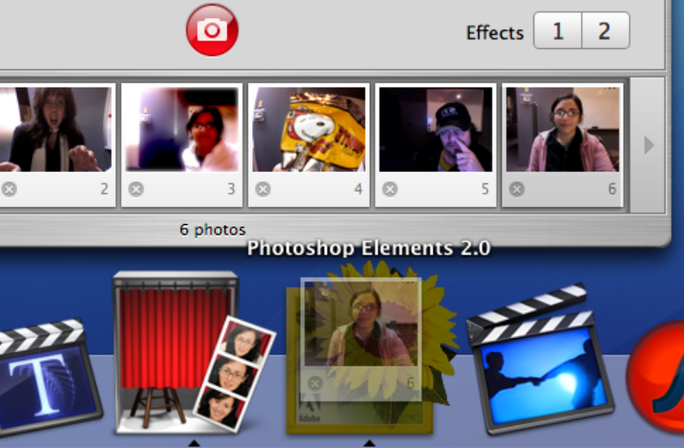

Here’s my picture

When dragging the picture, it will look faint. And I know Photoshop will take my picture because the icon is now grey.

To drop in the picture, let go of the mouse. Photoshop Elements automatically opens!

Get a picture of a place - Find a picture on the Internet

Find a place you want to be – like Mt. Rushmore, the Grand Canyon, Antartica, the
Pyramids, the beach, London, ANYWHERE!

Here’s some options on where to find the pictures:

- Go to Google.com and pick the “Images” option. Type in a place. When you find a picture you like, COPY it and then PASTE the picture into a new document in Photoshop Elements
  - (HINT – don’t copy the little picture on the google page because the picture will be small and bad quality. Open the page, find the picture, then copy).

- Go to a website like www.sxc.hu or www.freefoto.com or www.freephotosbank.com or www.imageafter.com or www.flckr.com
  - Use the SEARCH box to find a place or find a list of categories and chose a city or a place of interest like the beach

How to COPY and PASTE –

When you find your picture, you will need to do a “right-click” to find the secret menu. Since Macs do not have the right-click button on the mouse, we have to use the keyboard to get to this secret menu.
- Place the cursor on the picture
- Hold the CONTROL key on the keyboard (under the shift key)
- While holding the control key, click the mouse
- A secret menu pops up like this:
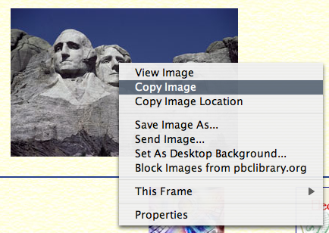
- Click on Copy Image

- Go to Photoshop Elements
- Under the FILE menu, go to

NEW FROM CLIPBOARD
- There’s your picture!

Now you can start editing

Some hints to get you started:

The tool bar is on the left. Everything you want is there.
If you want to know what each button is, put the cursor over the button and a title will pop up like “lasso too” or “move tool”
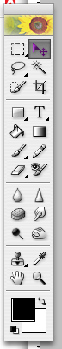

In this activity, we’ll be using the

Move tool – to move an object, such as the picture of yourself

Lasso tool (and this opens up to more options when you hold down on the button)
- allows you to select an object or area (useful when you want to cut
yourself out of a picture)

Crop tool - if you want to crop or cut off the edges of your picture

Text tool – if you want to add a title or your name to the picture

Blur tool – to soften the edges around a layer

This is where you select colors. We won’t be using the colors unless you want to add a title with color, but just so you know.

To UNDO something - go to the EDIT menu, and the first option is UNDO
Shortcut on the keyboard – hold the apple key (next to the space bar) and z

Remember to SAVE – FILE menu, then SAVE. Or shortcut – apple key and s

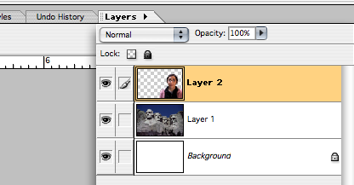
One more hint: Photoshop uses LAYERS.
If you are having trouble moving a picture,
make sure you are on the correct layer.
Change the layers using the LAYERS TAB
on the top, right side of the screen.

The picture of just you is one layer and the
picture of the place you picked will be another layer.

Here’s how to put YOU into the scenic place you picked.
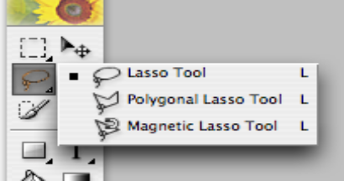
Selecting just you

Choose the Magnetic Lasso tool by holding down the mouse
on the lasso tool until you get the menu to choose the other tools.
Draw the mouse around your image. Hopefully the line will
drop on your outline.

Once you have the image selected just the way you want it, right click on the image (remember, hold the control key and click the mouse) and choose Layer via Copy.

Moving you to the new picture

Make sure you have both pictures open and you can see both at the same time.

Using the Move tool (the one that looks like a cursor), drag the layer of your body on to your scenic image. Let go of the mouse to drop your picture into the new background.

Continue to move this layer into place, making it look as if it is one photo.

** If you need to change the size of the place picture or your picture:
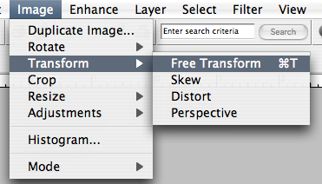
- Check the LAYERS tab to make sure you have the right
picture you want to edit selected
- Go to the IMAGE MENU, go to TRANSFORM and
select FREE TRANSFORM
- To scale evenly, hold down the shift key while dragging
the edges of the image to make it smaller or larger
- Hit the Enter key when you are finished

Blending the two layers

To make the picture more realistic, we sometimes have to blend, or soften the edges, of your body layer to the place layer.

- Check the LAYERS tab to make sure the picture of YOU is selected
- In the toolbar, pick the BLUR tool (the teardrop)
- To change the size of the blur circle and the roughness, go to the top of the screen and find this:

Play around with the options. If you don’t like how the blur turned out, Undo your actions.

Save the picture and you’re done! Now email it or print it and show off your skills.

